HPAC – Meeting Minutes

Date: 05/22/2019

Steering Committee — Chair: Gunner Scott; Vice Chair: Craig Rankin; Secretary: Chris Kallin; Treasurer: Michelle Glassley (2018)

PRESENT: Gunner Scott, Craig Rankin, Chris Kallin
ABSENT: None
GUESTS: West Seattle Blog, James Le, Members of the South Delridge and Riverview area committees.

Welcome: Gunner calls meeting to order and leads a round of self-introductions
Announcements:
- HPIC got a grant from 4Culture to replace the sagging beam.
- Anecdotal report on the HPIC wine event was that it went quite well.

Highland Park Way Project Update: James Le gave us an update about the Highland Park Way roundabout analysis. He stressed sightline issues with predictable crash patterns. Applied for state grants unsuccessfully 3x. 500k was allocated for grant matching, etc. Some light updates were made using 150k, which included painting and light curbing, and a survey to determine roundabout feasibility. 350k remains. Project submitted to street fund, which might give as much as 1M more. Grading is an overwhelming issue for the roundabout. Currently at 11% grade, a roundabout would be extremely expensive, but clearly the best alternative. Traffic signal concept would be closer to 3M and might be easier to include other local stakeholders for additional funding, but does not address all of the problems that the roundabout would.

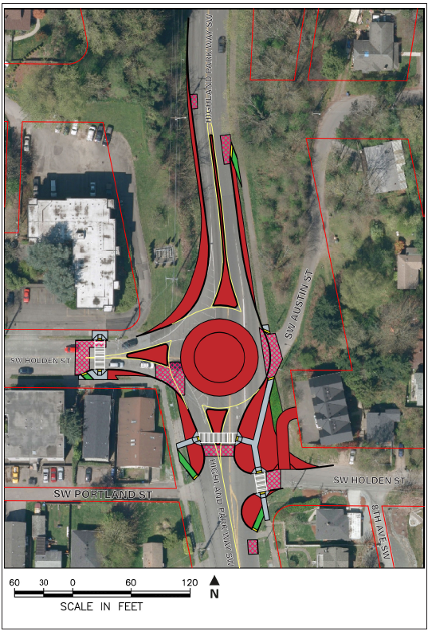
Q: If we went with the traffic light, would SDOT have a plan for the cut-through traffic in the neighborhood?

A: Will look into it.

Q: Why does the cost estimate keep increasing so significantly? It was 1M-something and then 3M-something and now 7M-something. Why is this?

A: Original cost estimates weren’t based on design / engineering. Original budget allowed for the survey and study.

Q: Skepticism expressed about NSF funding….

A: Noted.

Q: What is SW Holden classified as now? Arterial?

A: Highland Park Way north of Holden is a principal arterial. Holden as well. South of Holden is a minor arterial.

Q: What’s involved in principal arterial designation?

A: Car volume and number of accidents per day, carries regional traffic as opposed to neighborhood only.

Q: We are one of three ways off the peninsula, so what does it mean if one or more ways were defeated due to disaster?

A: James establishes a disaster planner, but can connect you with one.. maybe the name is Eichorn? Also, the Policy and Planning Group looks at the long-term, long-range master plans.

Q: What about Olson Place & Roxbury? Can you see who the contact is about that and have them attend our Fall meeting as well?

A: Will look into it and make that request.

Q: Also 16th & SW Holden… Bike / PED / master plan. Can you nudge all the right people to attend our Fall meeting? We’d like it to be a bit of a summit.

A: Nod and note-taking

Gunner: Wraps up saying he’ll be in touch to ensure that the right people are present for the West Seattle Transportation Coalition summit in the September meeting.

Neighborhood Groups Merger:
SDCG, HPAC, and Riverview Neighbor Community Groups Merger Discussion and Vote
Resolution to combine the neighborhoods of South Delridge, Highland Park and Riverview into one neighborhood council.

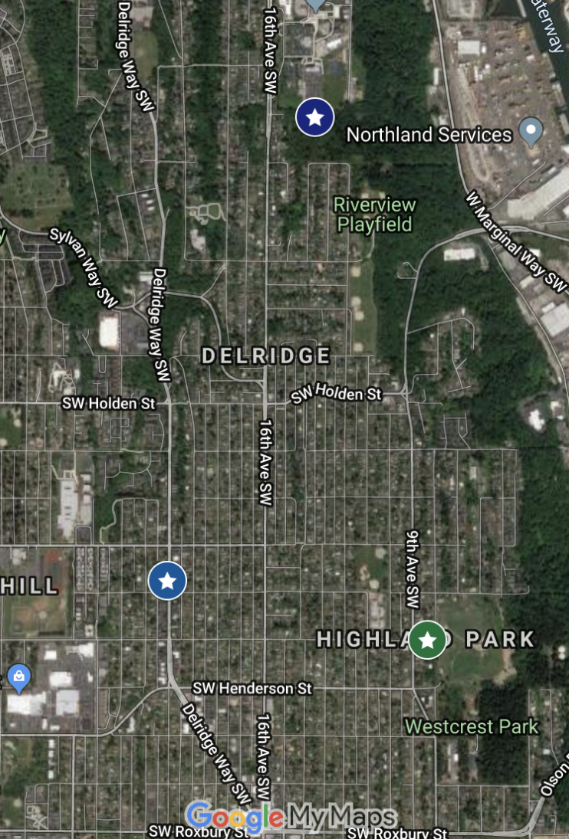

A request has been made to merge the neighborhoods groups east of Delridge Way in the southern section of the Delridge Corridor. We are proposing one neighborhood council for Highland Park, Riverview and South Delridge. HPAC has had representation from Riverview neighbors for the last few years and would like to formally include Riverview with this proposed merger. The neighborhood boundaries have been fluid between these three neighborhoods and neighbor leaders from South Delridge, Highland Park, and Riverview have worked together on a number of projects and issues over the last 2+ years.

Voiced during discussion:
- Lines blurred between groups.
- Stronger voice, as we’re all working on similar issues.
- Working close together anyway, let’s just formalize it.
- Presents an efficiency to the various councils and agencies we request time and resource from… less fragmented...

MOTION (called by Craig and seconded by Gunner): HPRVSD Coalition is unanimously voted for: 10 yes, 0 no

- No abstains or objects other than a concern about the loss of hyper-neighborhood concerns, and the possibility of them being overshadowed by the larger, broader issues we all share.
- Mary Anne volunteers to be Vice Chair of the executive committee for the first year.
- Agreement to hire Deena to update or create a logo.
- Continue to use the HPIC list-serves and add “neighbors advocating for”… to the newsletter...

HPAC Committees:
- Riverview Fence Project Update - June 6th, Thursday evening at 6:30pm walking the site to discuss project.

Preview Next Month’s Agenda:
- Discussion on Micro Policing Plans for Highland Park, Riverview, and South Delridge

Community Events & Meetings:

> Happening at Highland Park Improvement Club (HPIC)
- 1st Fridays – Corner Bar
- 2nd Fridays ART LOUNGE Art Class + community art lounge + HPIC bar
- Mondays and Tuesdays 7:00 pm Yoga Flow All Levels
- Thursdays 7:00 pm Punk Rock Aerobics

> Delridge Neighborhood District Council: Monthly Meeting 3rd Wednesday at 7pm – See Facebook page for location.

Also of Note / Call for Action:

> Your Voice Your Choice Project Development Phase
In Project Development, community members take the ideas submitted during the Idea Collection phase and prioritize them to 8-10 ideas per Council District. A map of all project ideas is now available and we hope you will share your opinion. Project Development ends on May 31, 2019.

- There will be opportunities to participate in Project Development meetings in each Council District. Participants will be responsible for evaluating the project ideas that are submitted and give each project numerical ratings.
- Each Project Development meeting will be supported by Your Voice, Your Choice staff who will ensure that community members have the necessary resources and tools to evaluate projects.
- Anyone can participate in Project Development if they live, work, go to school, receive services, volunteer, or have a connection to the City of Seattle.
- Project lists will be divided geographically within Council Districts. We will provide information in advance on which lists will be discussed at which meetings.

District 1 - Project Development Meeting
May 28, 5:30 - 7:30pm @ South Park Community Center

HPAC requests you please vote for these Highland Park and South Delridge YVYC projects. If you are interested in ranking the project ideas online, go to https://yvyc.consider.it/.

Council District 1
Pedestrian safety
- 19-10 | District 1: 9th Ave SW from SW Kenyon St., SW Elmgrove St. to SW Thistle St.

Speed deterrent
- 19-11 | 11th SW, 12th Ave SW, 13th Ave SW, and 14th Ave SW between SW Holden and SW Kenyon St.

Pedestrian safety improvements
- 19-22 | Olson Place SW & SW Roxbury St https://goo.gl/maps/ishfQu42iD62

Traffic circle
- 19-23 | SW Elmgrove and 12th Ave SW, Highland Park, West Seattle

Pedestrian safety improvements
- 19-24 | 16th Ave SW & SW Holden St., Highland Park, West Seattle

Sidewalks and curb cuts
- 19-43 | SW Barton St between 21st Ave SW and SW Barton Pl

Increase visibility
- 19-54 | 18th Ave SW and SW Webster St

Your Voice, Your Choice: Parks & Streets is a participatory budgeting initiative in which Seattle residents democratically decide how to spend a portion of the City's budget on small-scale park and street improvements.

If you cannot attend a meeting, but would like to evaluate projects, you can do so online until May 31, 2019.

