HPAC – Meeting Minutes

Date: April 24th, 2019

Steering Committee — Chair: Gunner Scott; Vice Chair: Craig Rankin; Secretary: Chris Kallin; Treasurer: Michelle Glassley (2018)

PRESENT: Craig Rankin, Chris Kallin, Michelle Glassley

ABSENT: Gunner Scott

GUESTS: Barb Biondo (concerned neighbor and co-facilitator)

Community Announcements:

Highland Park Improvement Club (HPIC)
- 1st Fridays – Corner Bar
- 2nd Fridays ART LOUNGE Art Class + community art lounge + HPIC bar
- May 18th UNCORKED - Big Fundraiser

- Mondays and Tuesdays Yoga Flow All Levels 7:00 pm
- Thursdays Punk Rock Aerobics 7:00 pm
Highland Park Action Committee (HPAC)
- May 4th - Clean-up
- May 4th - Insect Walk
- June 1st - 10am - Duwamish Hike - Start at Chinese Gardens, down through to Longhouse (and back)
- August 31st - SW Historical Society History Ride - Topic is historical meeting places - Starting at HPIC
Delridge Neighborhood District Council Monthly Meeting
- 3rd Wednesday of each month at 7PM – See Facebook page for location
West Seattle
- May 11th - Garage Sale day - About 250 signed up

Community Group Updates:
Riverview Ballfields Fence Discussion
Facilitated by Barb Biondo & Craig Rankin

Backstory: 3-years ago, a Find-it Fix-It walk with the mayor… the creosote logs were pointed out… interest in something non-creosote when replaced. This led to a fence appearing on the lawn at the park three week ago. There was an immediate outcry about the sudden appearance of an unpopular solution.

Barb Biondo introduces herself and how she came to be “nominated” as the point-person for the fence issue. She doesn’t see herself as the point person, but she sees herself as a neighbor with an idea and wishes to share. Apparently there are bids being solicited to remove existing fence as the unfinished product is now seen as a hazard.

Kay suggests that it might have been considered by the city, from only a maintenance aspect. Another neighbor recalls how they were installed 30-some years ago. A Riverview committee member worked at City Light and could get the used lights for free and had them installed to dissuade people from driving on the field.

Talk about starting a Friends-Of group (city and parks are used to talking to these groups) that aligns with HPIC/HPAC in order to add visibility and a point of contact.

Barb suggests that we individually consult or do homework to come back with strong ideas about what to replace the fence with.

There’s a suggest to solicit top 3 approved from parks on what works and is approved at other parks they manage. Bring those to the table so they can be considered neighbor ideas. Also a call for visibility to the parks’ plans, so we’re not hit with surprise in the future.

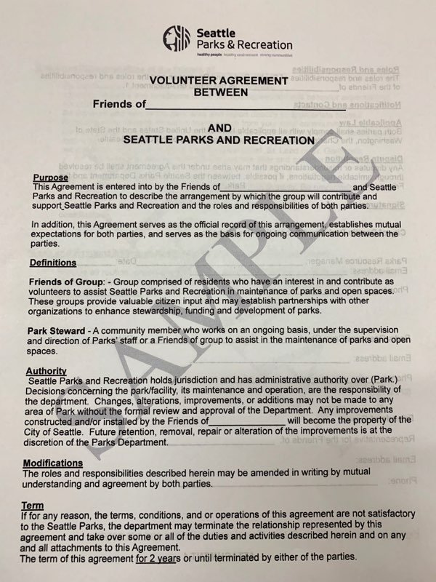

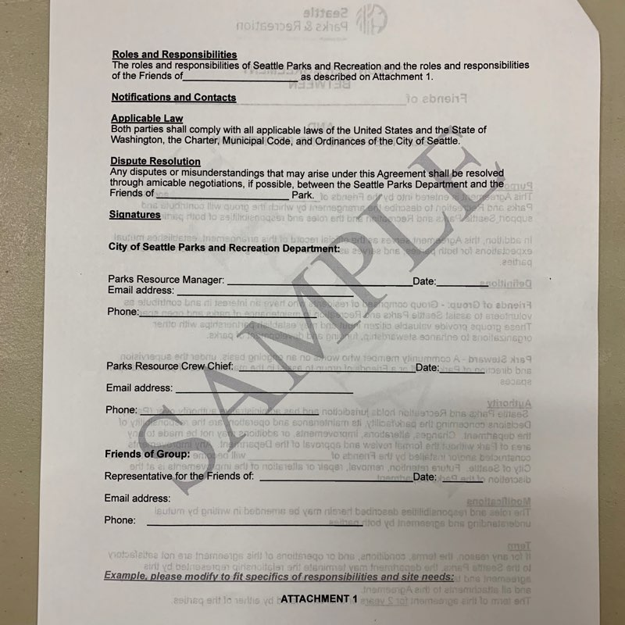

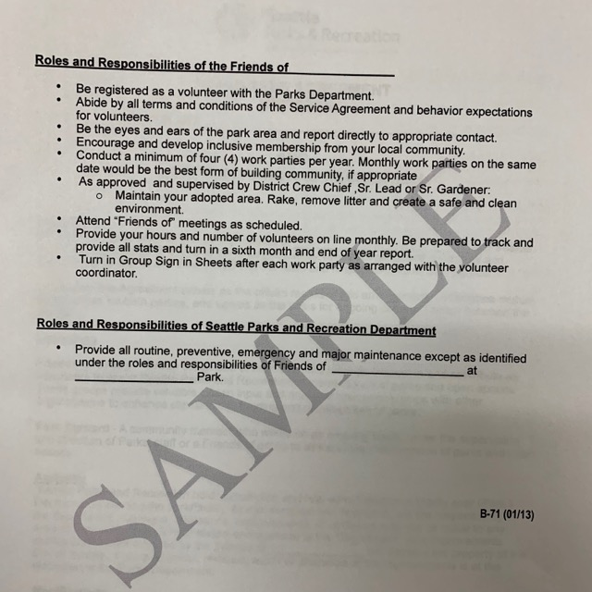

Agenda Items for Next Meeting:
- Highland Park Way & SW Holden St. Intersection Improvement Project, Presentation & Update from Adonis Ducksworth (Capital Projects Coordinator, SDOT)
- Coalition / Merger: S Delridge, Riverview, Highland Park

